Social Justice
There are many charities listed under CCFD’s eleven umbrella agencies that are advancing social justice. Please consider donating to these agencies to support healthcare rights, protect vulnerable adults, children, and families, and fight for racial justice. Click on the links below for more information.
Local:
Champaign County Health Care Consumers is dedicated to the mission of working for quality affordable health care for all, and for environmental health and justice. CCHCC organizes individuals and communities to have a voice in the health care system and to affect social change to achieve health justice.
C-U at Home is a grass roots, not-for-profit committed to serving the most vulnerable in the Champaign Urbana community with emergency shelter and other vital services.
Crisis Nursery creates an "Island of Safety" dedicated to prevention of child abuse and neglect through 24-hour emergency care for children and support for families in crisis.

Statewide:
Black United Fund of Illinois is a non-profit, tax-exempt federated organization and a social movement designed to improve the quality of life for African Americans through reliance on self-help at the local community level.
National:
NAACP Legal Defense and Educational Fund, Inc. is America’s premier legal organization fighting for racial justice. Through litigation, advocacy, and public education, LDF seeks structural changes to expand democracy, eliminate disparities, and achieve racial justice in a society that fulfills the promise of equality for all Americans.
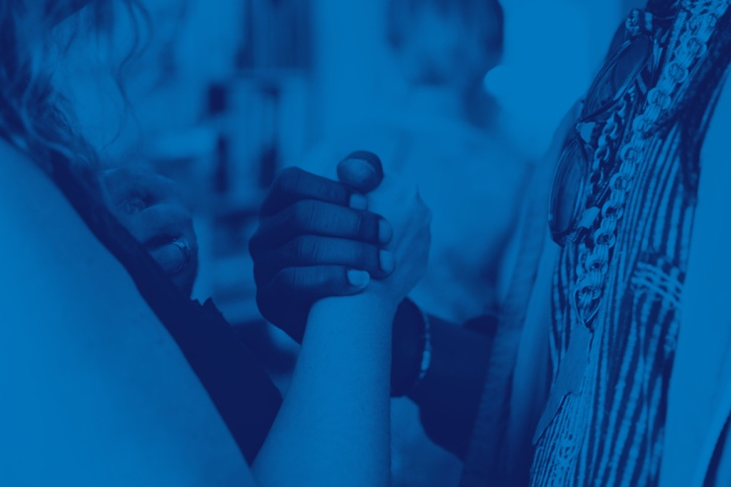

Environmental Wellness

From clean air to safe drinking water to policy to education, please consider donating to one or some of these agencies to help promote environmental wellness for our future generations.

Beyond Pesticides prevents pesticide poisoning of our environment, homes, workplaces, schools, food and water through a practical information clearinghouse on toxic hazards and non-chemical pest control.
Champaign County Environmental Stewards reducing pollution through material management solutions.
Environment Illinois (formerly Illinois PIRG Educational Fund) investigates problems, educates the public about solutions, and organizes for safe drinking water, clean air, toxic education, solid waste, safe, affordable energy, and environmental preservation.
Natural Resources Defense Council works with communities, officials, and businesses to secure laws and policies that will protect our environment for years to come.
Earthjustice wields the power of law to preserve magnificent places and wildlife, protect people's health, advance clean energy, and combat climate change without charging clients.
The Sierra Club Foundation, Illinois Chapter promotes climate solutions, conservation, and movement building through a powerful combination of strategic philanthropy and grassroots advocacy.
COVID-19 RESPONSE
There are a multitude of charities listed under CCFD’s eleven umbrella agencies that are tackling the COVID-19 crisis through programs, relief efforts, and a variety of initiatives. Please consider donating to these organizations to help your fellow Champaign County neighbors, Illinoisans, US citizens or people around the world.
Below, you will find what some of this year’s designations are specifically doing to provide COVID relief. Click on the links for more information.
American Lung Association’s $25M COVID-19 initiative will be used to:
- Provide free lung health education and masks to those in need
- Protect public health by advocating for COVID and flu vaccines in underserved communities of color
- Prevent future outbreaks by investing in respiratory virus research
AmrefHealth Africa’s COVID-19’s response focuses on:
- Training health workers
- Access to clean water and proper sanitation
- Testing and laboratory strengthening
- Mitigating the secondary impacts
Aunt Martha’s Health & Wellness’s COVID-19 mobile units bring access to testing and other health services to remote areas and communities in need.
- No out-of-pocket cost regardless of ability to pay
- No doctor’s note needed
- Covid-19 symptoms are not required to get tested
Direct Relief’s COVID-19 relief activities are focused on four key areas:
- Providing personal protective equipment (PPE) to safeguard health workers
- Deploying medication needed for intensive care units to expand the capacity to care for ICU patients
- Boosting support to safety-net facilities to address existing chronic gaps that are likely to grow
- Collaborating with infectious disease epidemiologists, technology companies and public agencies to use aggregated mobility data to support the COVID-19 response.
Hope Worldwide, Ltd. has been actively responding to this crisis by providing food, medical supplies, educating families and on-going support for those negatively impacted by the worldwide pandemic.
Partners in Health has launched a comprehensive effort to support this response across its network of supported countries around the world to:
- contain and control the spread of the virus
- ensure that patients are provided with dignified care
- demonstrate to the world what aggressive action in vulnerable settings can achieve.

Project HOPE’s strategy focuses on:

- providing lifesaving protective gear in high-risk areas
- training health workers to recognize and treat COVID-19
- deploying medical volunteers to provide surge staffing
- helping health systems around the world ensure continuity of health services

United Way of Champaign County Health Focus
The long-term recovery of our neighbors impacted by the pandemic will be a core part of United Way's Community Impact Fund in 2021. The Community Impact Fund is flexible and responsive, focusing on building equitable and more resilient communities through improved health, education, and financial stability.
The tough work that will be needed to help communities recover is the very work United Way does every day:
- We help feed those facing food insecurity
- We prepare children for success in school, work, and life
- We connect those in financial distress with resources to pay bills and stay in their homes
